Logos 8
Functional Technical Description

Document Goal
The purpose of this document is to give a short functional description of the Logos8 product and of the technical components which make up the Logos8 product. This document will first describe the 8.2 version of Logos8 and then indicate what is or is not in the 8.0 and 8.1 releases of Logos8.

General
Logos8 is the latest version of the Logos MT product. It is the redesign and conversion of the old Logos7 product to new system architectures and software programming languages. Logos8 will have all the functionality of Logos7 with significant functional enhancements to the terminology management tool (ALEX) and job management tool (LogosClient). The product has been developed using the latest in software design techniques and programming languages such as relational databases, 3-tier architecture, c++, and Java. Logos8 will run on Windows NT with an Oracle database. It can be ported to other platforms and databases, such as Sun and MS SQL Server, as market requirements dictate.
This product will be the foundation on which major linguistic improvements will be based upon. Increased lexicons, enhanced rule bases, better linguistic development tools, and additional language pairs are just a few examples of enhancements which will be possible with Logos8 as a foundation.

User Interfaces
There are 2 user interfaces to the Logos8 product; LogosClient which allows for submitting and retrieving jobs, and ALEX which allows users to modify the Logos dictionary. Both applications are client/server based and written in Java.

LogosClient

Functionality
The current Logos client will be enhanced and modified to connect to the Logos8 server.
The basic functionality will remain the same with the following modifications.
- A tab will be added to support a link to ALEX from LogosClient.
- The database for storing jobs will be the same database used by Logos8 server and ALEX
- Jobs will be managed directly by the LogosClient server and not by a Logos scheduler as is done now with Logos7.8
- Some look and feel aspects will be adjusted to give LogosClient and ALEX a consistent look.
- User management features will be enhanced to support ALEX requirements for privileges and access rights. For example what users can use ALEX and what users can modify the Semtab rules

Architecture
LogosClient is a client/server application written in Java using Java RMI to communicate between the client User interface and the Java server component via a defined socket. The client should run on Windows 95, Windows NT, Windows 98, most Unix systems and Mac. There will be some versions of Unix and Mac that will not support LogosClient because these operation systems do not support Java. Java JDBC is used on the server side to connect to the relational database.

APIs
Application program interfaces will be available to allow third party applications, such as word processors and sentence memory products, to submit text for translation. These APIs are already available in the 1.2 version of LogosClient.
They are written in Java Beans with an ActiveX wrapper to allow applications that can not communicate with Java Beans to use MS ActiveX interfaces.
The first use of these APIs and integration between Logos MT and TM will be the IBM TM/2 TM product to be released in the fall.
We plan to Integrate LogosClient with TM products from STAR and TRADOS as well.

ALEX

Functionality
Alex is a graphical user interface which will allow users and Logos developers to browse and modify terminology or semantic rules stored in the server database. This application can be run within a local network or remotely by users through the internet.
ALEX can be called up from the LogosClient user interface or as a standalone user interface.
Users of the Logos7.x product will notice that SEMANTHA is no longer a component of Logos8.x. The SEMANTHA functionality is integrated into the ALEX interface. Users can go from adding terms to adding rules right inside ALEX.

Browse
To browse the Logos dictionary the user must fill in the selection and sort criteria in the filter dialog to select the entries to be displayed in the dictionary view window. The filter dialog allows users to select entries by date, by user, use wildcards, etc..
The following is an example of the filter window.
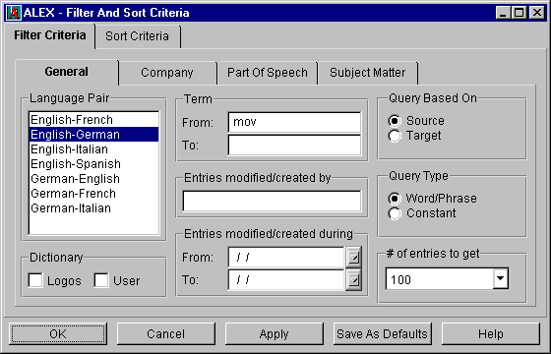

The view of the entries selected is displayed in a window in tabular format as illustrated in the figure below. User can use the scroll bar or the previous and next buttons to view the list.
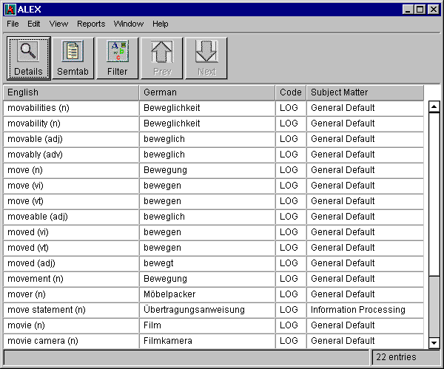
Users can view the detailed attributes of a selected entry by pressing the “Details” button which will display the following window. Note that the amount of information displayed in the detail window is determined by the privileges setting for this user. Developers would see more detailed attributes than customers.
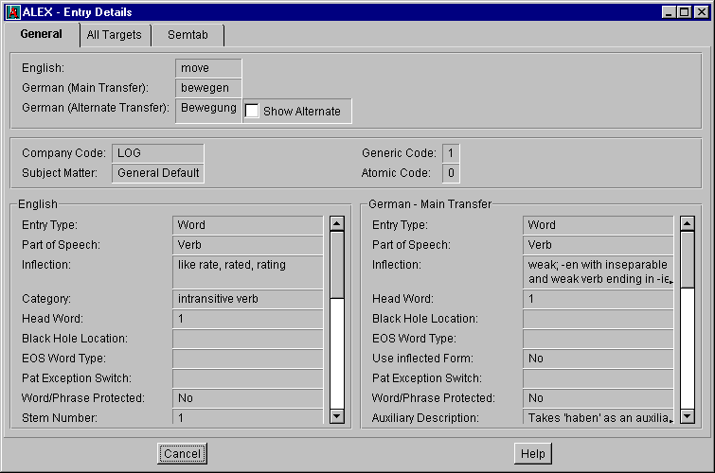
Semantic rules for a selected term may be displayed by clicking on the Semtab button which will cause the following window to be displayed.
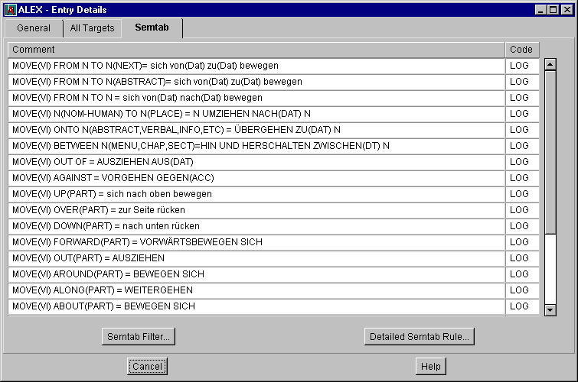

Add, modify, delete
Users will be allowed to add, modify, and delete terminology from the dictionary.
Users will not be allowed to modify Logos entries.
Users will not be allowed to update new verbs. This will be possible in a future release.
Terms can be added automatically through the import feature of ALEX. The SAL and other coding will be assigned by the new AutoCode logic.
The same Semantic rules which can be added with the Logos7.8 SEMANTHA product can be added to the Logos8 dictionary.

Import
ALEX will accept 4 types of file formats for import;
- simple ASCII semi-colon delimited
- Logos LEF
- The output from a Logos Term search job.
- Logos dictionary object format.
This Logos proprietary format would be used to export terms from the Logos release dictionary and import them into a user dictionary when upgrading users to a new release.
We will allow for more formats to be added later.
There will be 3 modes of importing entries;
- Automatic - will autocode all entries and store them in the dictionary. Errors will be reported to a file.
- Manual – each entry will be displayed in the ALEX add dialog to allow the user to fill in and modify any attribute before the entry is added to the dictionary. Users can select to discard the entry as well.
- Semi-Automatic – entries will be autocoded and stored in the dictionary unless the coding of the entry can be determined to be questionable. If this is the case the entry will be displayed to the user to confirm the coding, the user will modify any attributes, hit enter, and the automatic coding and updating will continue. This is a combination of the Automatic and Manual modes.

Export
Users will be allowed to export their entries from the dictionary. Logos entries can not be exported. ALEX will support 2 export formats.
- ASCII semi-colon delimited file.
Only a subset of the term attributes will be exported into the ASCII file.
- Logos dictionary object format
This Logos proprietary format would be used to export terms from the Logos release dictionary and import them into a user dictionary when upgrading users to a new release.
We will allow for more formats to be added later

Report
There will be 3 categories of reports;
- Predefined reports – These reports are canned reports that will be shipped with the product. For example there will be a “Time” report which the users will use to enter a date range, press enter, and a report of all entries added or modified during that time will be created.
- Customized – User can select what entries and what attributes for the entries should be written in the report.
- Favorites – A customized report can be saved as a “favorite” for later use.
There will be 2 formats for reports; tabular like what is seen in a spread sheet, and paragraph form such as found in a dictionary.
Users can save the reports as HTML files or print them.

User Privileges
Users must sign-on to ALEX by entering a userid and password. A profile will be created for each user by the administrator. This profile will control what functionality the user has.
- Logos Administrator Developer – All rights and privileges for Logos developers only
- Logos Developer – Modify dictionary for Logos developers only

- Administrator – Customer administration user.
- User – Customer user.
- Guest – Browse dictionary only. Can not modify dictionary.
Various functionality for users can be turned on or off by the administrator. The ability to modify the company code list and update Semtab rules are 2 examples.

Tools
The ALEX tool menu will allow the user access to the following tools:
- Company Codes / Subject Matter Codes
Users can modify the list of company codes and subject matter codes as well as adjust the default search order for these codes when terms are looked up in the dictionary during translation.

- Patterns
User will be allowed to add/delete/modify the list of patterns used during translation to protect strings from translation or correct output strings after translation.
- Stem and Inflection Rules (Logos developers only)
Developers can enter words and test how the stemming and inflection algorithms are working. Later we will add the ability to modify the rules and tables that drive this logic.
Additional menu items will be added to the “Tools” menu in ALEX for future tools both for customers and for Logos developers

Architecture
ALEX is a client/server GUI written in JAVA. The client interface communicates to a server component via Java RMI communication protocol over a defined socket. The server side component is also written in Java and connects to the Logos dictionary via Java JDBC protocol. Logos will ship to customers the needed Java runtime environment, JDBC driver, and Logos Java classes to run ALEX.

APIs
Application program interfaces (APIs) will be written to allow users access to ALEX functionality from third party applications. These APIs will be written in Java Beans with ActiveX wrappers for Windows applications which can not communicate with Java Beans.
We anticipate the following APIs:
- Find the passed term in the Logos dictionary and return the transfer.
- Add the passed term to the Logos dictionary. This will have the option to autocode the entry or display the add dialog window in Alex to allow the user to modify the default coding before the term is updated in the dictionary.
- Delete the passed term from the Logos dictionary.

Server

Functionality
The Logos server will run the same jobs as the Logos7.8 server: Translation and Term search. The LogosClient will control the job queue for the translation engine. As a result multiple jobs can be run at one time, the queue order of jobs can be reorganized, and jobs that are running can be canceled.

Data
Terms, Semantic rules, pattern matcher rules, and other small tables, such as never EOS list, will be stored in the relational database. This means that all data that is modifiable by the user is stored in the relational database.
Grammar rules are stored as files on disk along with the executables.
1gb of disk space should be reserved for Logos Data installation and expansion.
(This does not include the space required for the Relational Database product)

Architecture
The server software is written in c++ and Java with a relational database to store most of the data. It is a multi-threaded process which will be controlled by the server component of the LogosClient.
This server will run on Intel based Windows NT 4.0 with at least 128mb memory. It is recommended that a 400mhz Pentium CPU is used.
The Java runtime environment will be delivered by Logos to run the Logos Java programs.
1gb of disk space should be reserved for the Logos server.
Oracle database is required and can be installed on the same machine as the Logos server or on a remote machine. The remote machine running Oracle can be Unix or NT. ODBC driver is required for the Logos Software to connect to the database.
Depending on market demand and resources, it is anticipated that Logos will be ported to MS SQL Server database and Sun Solaris operating system.

Filters

Functionality
Filters for RTF, WinHelp, SGML, HTML, XML, Interleaf ASCII, and Frame Mif format will be delivered with the product. These filters will separate text from graphics and formatting, pass the text on to translation, and merge the translated text with the original graphics and formatting. The filters will process documents very quickly (in seconds).
Depending on market demand we could write additional filters for Word Native, Pagemaker, Ventura, or other formats.
We will not support WordPerfect native format.

Architecture
The document filters are written in Java and can process documents in seconds. Java was selected because it is a clean language that will be easy to support and will allow for double byte languages easily.
The Java runtime environment will be delivered with the Logos installation to run the filters.

Translation Memory

General
Translation memory products will use our new LogosCLient with the published APIs to submit sentences for translation. We plan to have all three major translation memory products integrate with Logos.

IBM
Integration with IBM TM/2 product is underway and will be demonstrated at the Lisa conference in August. This product should be released in the fall.

Star
Star has received the specs for the Logos API and have agreed to do the necessary work.

Trados
Trados has received the specs for the LogosAPI and have shown some interest in integrating.

Development Tools

Programming Environment
Software is developed using MS Developer Studio C++, Jbuilder and Symantec Cafe for Java, SourceSafe for source control, and Oracle for the relational database.

Submitting Jobs
Translation jobs are submitted using a prototype LogosClient written in MS Access. It is anticipated that this will be replaced by the LogosClient Java application. To do this we need to add development functionality to the LogosClient Java.

Terminology Management
We currently have 3 ways to manipulate the terminology database; PL/SQL scripts, Oracle Forms, and ALEX. We will continue to use PL/SQL scripts where convenient and migrate the Oracle Forms to Java and add the functionality to the ALEX tools menu.

Semtab
All modifications of the Semtab rules will be done through the Semtab windows of the ALEX user interface. This would include the user defined templates and the tools used by the developers.

Grammar Rules
The RES and Tran rules will be converted to object rule set files. These files will then be modified using the rule browser. The old text edit, check, generate, merge, and sort tools will be replaced by this rule browser. The ‘numbers’ are still the formalism until we (Logos) come up with an alternative formalism.
(Here is a shot of the main window. See demo coming soon…)
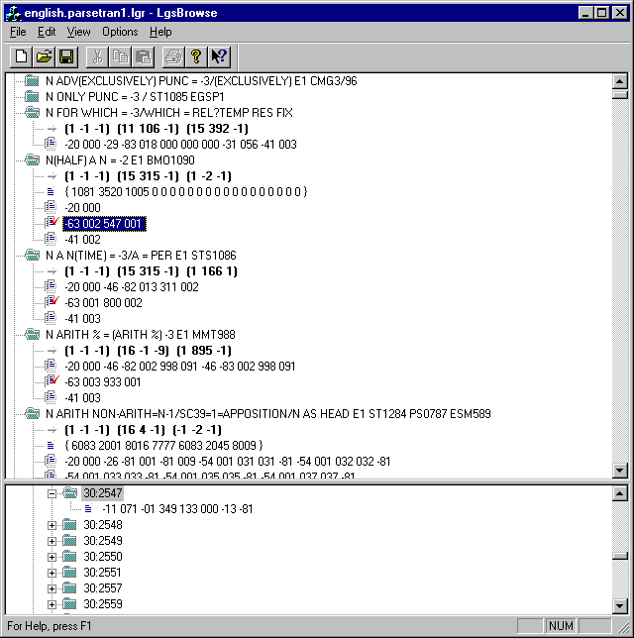

Diagnostics
Diagnostics will continue to be written out to a text file and can be viewed using a text editor as is done today. In addition we will develop a ‘diagnostic viewer’ that will allow developers to view the diagnostic in a more organized fashion. This diagnostic view will be linked to the rule browser to allow easy navigation from the diagnostics to the rule sets.
(Here is a shot of the main window. See demo coming soon…)
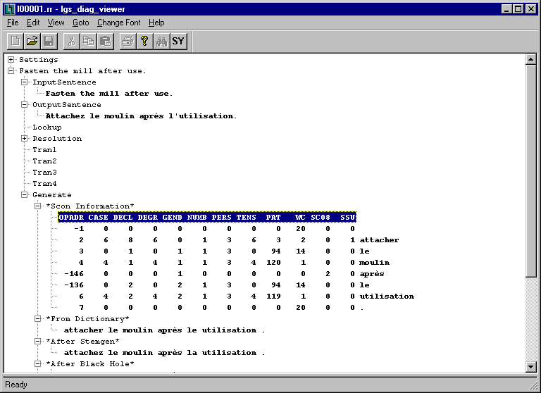

Help System

Milestones and Versions

Logos8.3
This is the final major release of the product and includes all the features and functionality defined above for all language pairs.

Logos8.2
This is the major release of the product and includes all the features and functionality defined above with the exception of the German-French and German-Italian language pairs.

Logos8.1
This release is everything in 8.2 with the exception of Semantha rule writing capability nor support for German-French and German-Italian language pairs for translation. Users will not be able to modify the Semantic rule database.

Logos8.0
This is a milestone benchmark in development. At this point we will have translations running on NT with the same quality of output as the Logos7.8 product. ALEX will not be ready and German source will not be of the same quality as 7.8.

Benefits of Logos8 over Logos7.x
It is important to understand the benefits of Logos8 from the customer point of view. The plan is to convert all customers from Logos7.x to Logos8. The following is a list of some of the features users will see in the Logos8 product:

- Product runs on Windows NT which is a system most customer would prefer over UNIX
- Database is a robust scalable commercial database. Problems with corrupt dictionaries and lost data should be greatly reduced.
- User interfaces are all GUI.
- User interfaces are java and networked enabled to allow for remote access to the product.
- Submission of long file names and lists from Windows environment.
- Semantha functionality is integrated into the ALEX user interface.
- Flexible reporting and searching of the dictionary.
- Many new features for managing dictionary; wild cards search, sorting, reporting, importing, exporting, etc….
(See ALEX demo for feature comparison.)
- Long entries can be added to dictionary.
- Faster and better filters which run in seconds and not hours.
- All management functions are accessable from LogosClient. Separate server side admin tool is not required.
- Better SMC and company code search order and management.
- Better and faster pattern matcher. Plus pattern rules can be modified from ALEX interface.
- Redesigned translation engine to c++ which will translated into faster turn-around time on fixing bugs.

